Rachel Rodriguez

Annaliese Wieler

Shuyue Li

Dynamic Modeling: Stability of Predator-Prey Dynamics

**Part I: Conceptual Models**

1. Lotka-Volterra box and arrow conceptual model

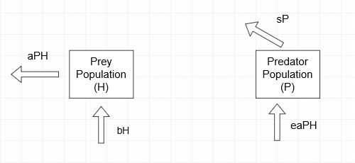

2. Rosenzweig-MacArthur box and arrow conceptual model

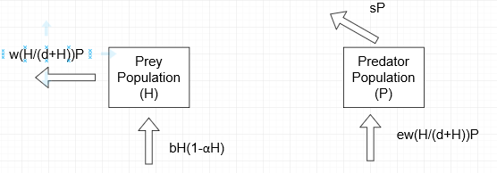

**Part II: Simulation of Lotka Volterra model**

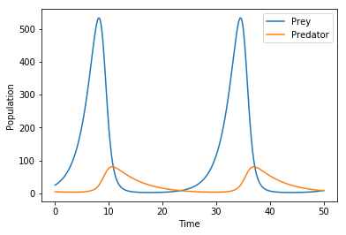

B = 0.5, a = 0.02, e = 0.1, s = 0.2, H = 25, P = 5

According to this figure, the predator and prey coexist very briefly; once the prey population rises, the predator population consequently rises as well - this may be because the predators now have more prey to eat. However, this creates a negative feedback, in which once the predators population increases, there is a decrease in prey, which then causes a decrease in predators.

1. Change b - prey birth rate

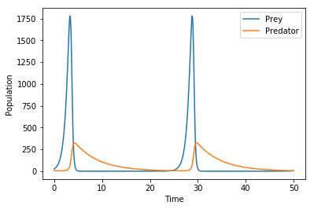

B = 1.5, a = 0.02, e = 0.1, s = 0.2, H = 25, P = 5

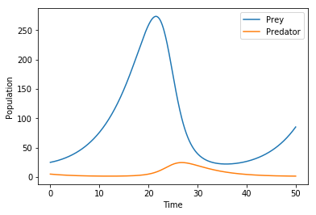

B = 0.17, a = 0.02, e = 0.1, s = 0.2, H = 25, P = 5

In this scenario, lower birth rate (b) leads to shorter maximum population amount for both predator and prey, while higher birth rate (b) results in longer maximum population for both populations.

2) change a - predator attack rate

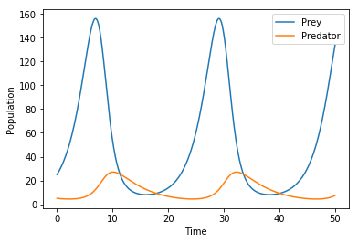

B = 0.5, a = 0.06, e = 0.1, s = 0.2, H = 25, P = 5

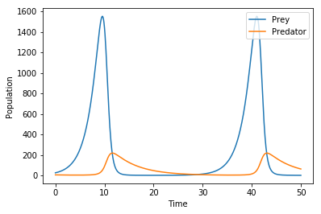

b = 0.5, a = 0.01, e = 0.1, s = 0.2, H = 25, P = 5

Increasing a will shorten time period, lower peak for both and slower changes, while decreasing a will cause longer time period, higher peak for both and faster changes.

3) change e - conversion efficiency of prey to predators

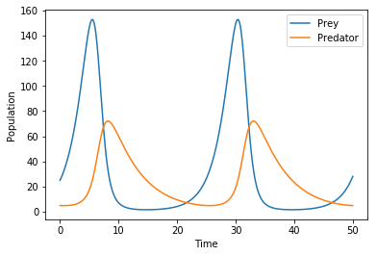

B = 0.5, a = 0.02, e = 0.3, s = 0.2, H = 25, P = 5

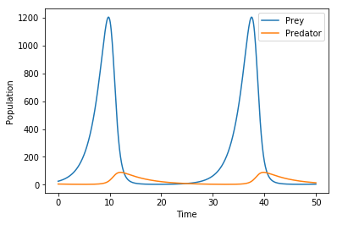

B = 0.5, a = 0.02, e = 0.05, s = 0.2, H = 25, P = 5

Increasing e can shorten cycling period, cause lower peak for prey population and slightly lower peak for predator population; decreasing e will lead to higher peak for prey and slightly higher peak for predator, but their period changing are not obvious.

4) change s - predator death rate

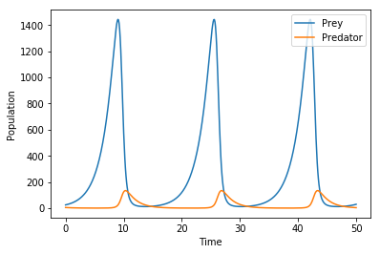

B = 0.5, a = 0.02, e = 0.1, s = 0.6, H = 25, P = 5

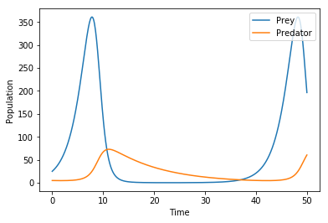

B = 0.5, a = 0.02, e = 0.1, s = 0.1, H = 25, P = 5

Increasing s can shorten cycling period and create higher peak for both populations; decreasing s will make longer cycling period, lower peak for prey, and slightly lower peak for predator.

*Answers to simulated Lotka Volterra models*

1. When all other variables are held constant, an increase in prey birth rate (*b*) creates a shorter time period between peaks in the population - which is indicative of an increase in the rate of change in the population. There is also a larger peak in the predator population, which makes sense because the prey population has increased so the predators have a more abundant resource with which to thrive. A decrease in *b* produces a longer time period between peaks, as well as a lower maximum amount of prey and a slower rate of change in both populations.

An increase in attack rate (*a*) creates more frequent peaks in both the predator and prey populations, however they are smaller in size - or rather, both have smaller carrying capacities. This makes sense because the predators are killing prey more frequently, leading to these rapid oscillations where the prey population gets reduced to zero causing a shortage in predators which then brings the prey population back up. Decreasing *a* leads to an inverse effect, in which the peaks in both populations are less frequent, but both populations have an increase in their carrying capacities.

An increase in efficiency conversion of prey to predators (*e*) causes a decrease in the carrying capacity of both species, however the predator population grows vastly larger than the prey population, as opposed to when *e* is decreased. So if there is high conversion efficiency, it can be assumed that since more energy is being brought up the trophic level, the predators are ultimately going to increase in population (perhaps by having more offspring).

When predator death rate (*s*) is increased, the prey population becomes less stable because the predator population is fluctuating much more frequently. A decrease in predator death rate is more stable for the predator population, causing the prey population to also stabilize and peak less frequently. This makes sense because when predator population is fluctuating less often, the prey population can stabilize itself without being constantly killed off.

1. In all simulations, it is clear to see their is a relationship between the abundance of predators and the change in prey populations. When predators increase in population at more frequent rates (more oscillations in the graphs), the prey population also tends to destabilize and peak more frequently. The graphs also depict a relationship in which the prey can only reach carrying capacity when the predator populations have already reached it and are declining - this is evident in all graphs presented, despite the changes in parameters.

1. Despite the fact that all parameters were changed independently (only changing one while keeping all others constant), a general trend in predator-prey cycle lengths was observed. In all cases, when you increase the value of a parameter you tend to see a shorter cycle length. This may be indicative of the fact that as predators increase and die off, the prey population takes advantage of the quick die off and begin to increase, but then also quickly die off once the predator population increases again. This seems to work as a negative feedback loop - as predators die off prey increase but this just leads to an increase in resources for the predators so now they’re population can increase again - it creates a race for constant stabilization between populations. It can also be observed that the peaks between prey and predator populations are separated at a 90 degree angle, in a trigonometric sense.

**Part III. Simulation of Rosenzweig MacArthur Model**

Baseline Model:

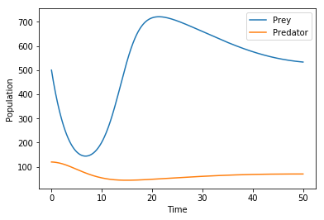

b = 0.8, e = 0.07, s = 0.2, w = 5, d = 400, 𝝰 =0.001

The initial model shows a strange slope and peak for the predator population. There is an initial dip (which you can see the prey population took advantage of - there’s a peak in prey at that time). After that, the predator population begins to rise again, stabilizing the prey population and causing it to be almost linear.

1) Changing b - prey birth rate

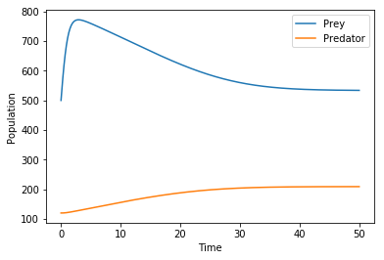

b = 2.4, e = 0.07, s = 0.2, w = 5, d = 400, 𝝰 =0.001

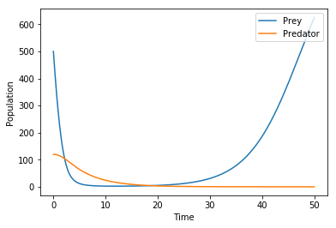

b = 0.2, e = 0.07, s = 0.2, w = 5, d = 400, 𝝰 =0.001

In this scenario, increasing b makes the low peak in prey population disappears, but prey eventually reaches the same equilibrium; decreasing b causes predators die out gradually (probably since preys are too few to support predators’ live), and then preys increase without constrain of predators.

2) Changing e - conversion efficiency of prey to predators

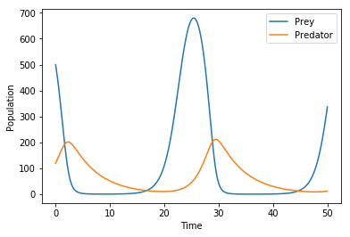

b = 0.8, e = 0.21, s = 0.2, w = 5, d = 400, 𝝰 =0.001

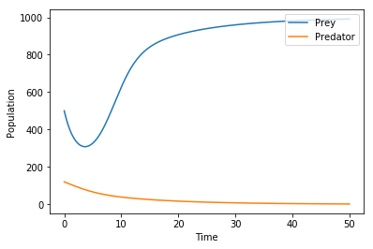

b = 0.8, e = 0.035, s = 0.2, w = 5, d = 400, 𝝰 =0.001

Increased e causes cycling of both population; decreased e makes predators eventually die out, while preys reach a maximum amount. It is possibly due to lowered conversion rate restricts the capacity that predators utilize preys to support their survival.

3) Change s - predator death rate:

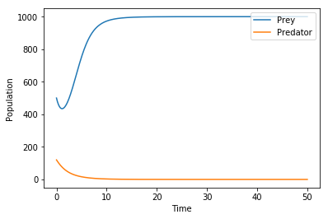

b = 0.8, e = 0.07, s = 0.6, w = 5, d = 400, 𝝰 =0.001

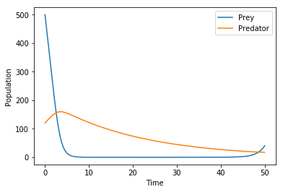

b = 0.8, e = 0.07, s = 0.05, w = 5, d = 400, 𝝰 =0.001

Because of increased s, predators eventually die out, while preys reach a maximum amount. By contrast, decreased s makes prey population drops fast (due to too many predators’ attack), following the decrease of predator population. After both of them decreased to a small amount, they continue grow, and possibly forming repeated cycles.

4) Changing w - predator attack rate:

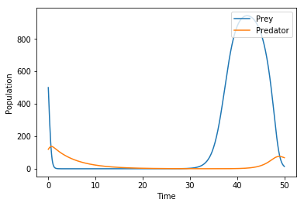

b = 0.8, e = 0.07, s = 0.2, w = 15, d = 400, 𝝰 =0.001

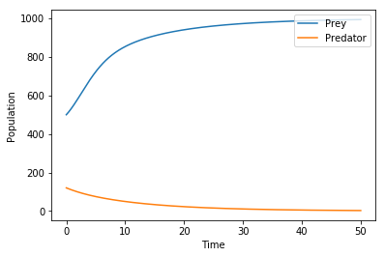

b = 0.8, e = 0.07, s = 0.2, w = 2.5, d = 400, 𝝰 =0.001

Increased w make prey population drops fast (due to too many predators’ attack), following the decrease of predator population. After both of them are decreased to a small amount, prey population booms, following the increase of predator population. In the contrary, decreased w makes predators eventually die out, while preys reach a maximum amount.

w in the equations basically has opposite effects of s.

5) Changing d - a factor limiting the predator’s maximum attacking capacity

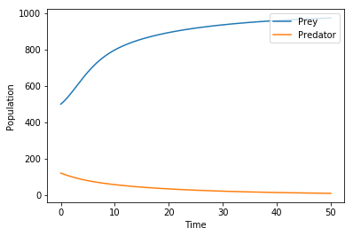

b = 0.8, e = 0.07, s = 0.2, w = 5, d = 1200, 𝝰 =0.001

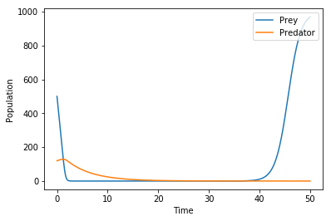

b = 0.8, e = 0.07, s = 0.2, w = 5, d = 100, 𝝰 =0.001

Increasing d can decrease the attack efficiency. The equilibrium amount of prey is higher while that of predator is lower, and they also reach equilibrium population faster. Decreasing d will increase the attack efficiency. Prey population drops quickly, leading to the drop of predator population. After that, they start cycling, though preys change dramatically while predators change slightly.

6) Changing 𝝰 - intrinsic limitation factor of prey’s growth

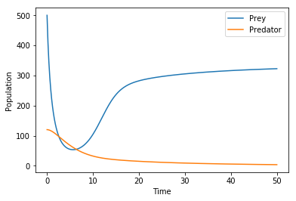

b = 0.8, e = 0.07, s = 0.2, w = 5, d = 400, 𝝰 =0.003

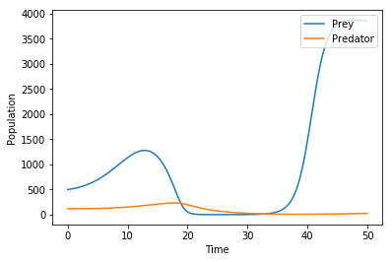

b = 0.8, e = 0.07, s = 0.2, w = 5, d = 400, 𝝰 =0.00025

Increasing 𝝰 leads to a slower growth of prey population, thereby they reach equilibrium slower, and at equilibrium status both population have smaller values. Decreasing 𝝰 causes prey population first increase, then decrease, then quickly increase again, while predators change following the preys. After that, both predators and preys start cycling.

*Answers to Rosenzweig-MacArthur model questions*

1. The Rozenswein-MacArthur model differs from Lotka-Volterra in the fact that it is not as linear as the Lotka-Volterra model. According to the Rozenswein-MacArthur model, without the predators, the prey cannot grow exponentially, as it would in the Lotka-Volterra model (or a type I response). Instead of the predators eating more when there is more prey, its limited to a certain amount as well.
2. The parameters that are shared between the Lotka-Volterra and Rosenzweig-MacArthur maintain the same type of influence between the models. However, the Rosenzweig-MacArthur model contains two additional parameters to limit the growth of both populations - 𝝰 and *d*. The intrinsic limitation factor for prey growth (𝝰) parameter is the inverse of the carrying capacity - when alpha decreases the carrying capacity increases and vice versa. The second parameter (*d*) is a limiting factor which when increased causes an increase in the time it would take for the population to reach carrying capacity. This affects the predator population primarily, but ultimately affects the prey population as well because it changes the rate in which they get eaten.
3. As an overview, some parameters are directly affecting the predator (such as death rate), while other parameters are not. The parameters which do not directly affect the predator population, primarily affect the prey population. However, in doing so, the predator population is shifted as well - due to the nature of the predator-prey relationship. If there are larger peaks in prey population, the models show larger peaks and crashes for the predator population as well, and if the prey population is able to stabilize, usually so does the predator population.

**Part IV: Simulation of Paradox of Enrichment**

K=2000 (𝝰=0.00050)

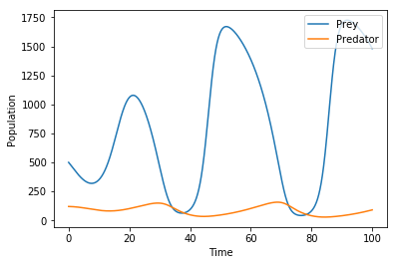

K=1333 (𝝰=0.00075)

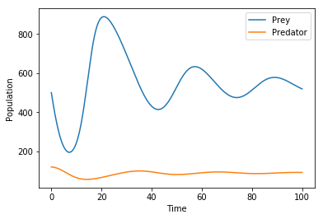

K=1000 (𝝰=0.00100)

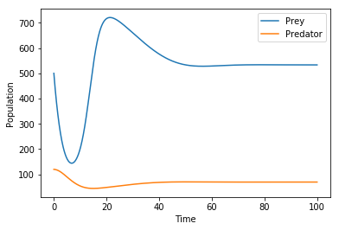

K=800 (𝝰=0.00125)

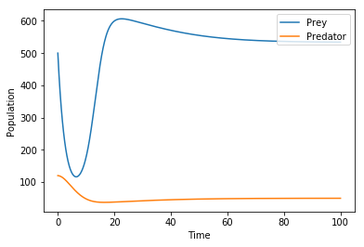

*Answers for Paradox of Enrichment*

1. Carrying capacity of prey (*K*) is negatively correlated with population stability of predator.
2. We see the Paradox of Enrichment because the increased carrying capacity leads to the prey population growing very large, and thus the predator population grows very large. However, the predator population eventually grows to such a large population that its existence is unsustainable, leading to a sudden decrease in predator population.